Dis-Eur-Spain-Venus Figure-3000 BCE

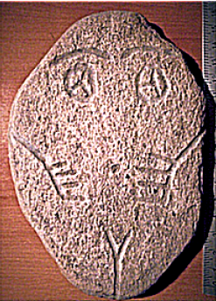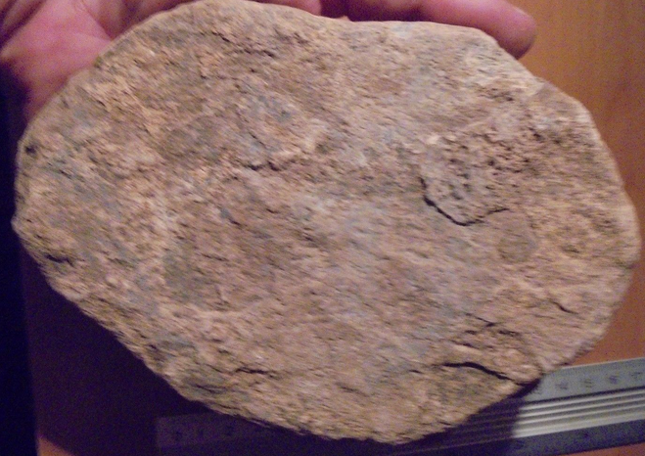

**Iberian Neolithic Two Dimensional Venus Figurine of Silicified Sandstone**

**Formal Label: Iberian Neolithic Two Dimensional Venus Figurine of Silicified Sandstone**

**Accession Number:**

**Date or Time Horizon:** 3000 BCE

**Geographical Area:**

**Cultural Affiliation:**

**Medium:**

**Dimensions:**

**Weight:**

**Provenance:**

**Condition:**

**Discussion:**

**References:**